# Background

Blood glucose levels are important physiological parameters when evaluating the impact of obesogenic diets. While zebrafish are popular model organisms, their size presents a challenge when collecting blood to obtain metabolic data. Traditional methods rely on complex assays to measure glucose levels; however, large volumes of blood are usually required (Bartoňková, Hyršl and Vojtek, 2017). This method is impractical for zebrafish, unless blood is pulled, which is less than ideal when interested in between-individual variation. Handheld glucose meters represent valuable alternatives to measure blood glucose levels in fish (Beecham, Small and Minchew, 2006). Their portability and ability to produce accurate results with small sample sizes make them ideal for field experiments and those looking to cut time and costs associated with heavy lab work. This protocol describes the use of FreedomStyle Freedom Lite glucose meters. The basic methodology involves dipping replicate test strips into cardiac blood directly after decapitation, similar to other studies (Gleeson, Connaughton and Arneson, 2007; Eames *et al.*, 2010). Pilot runs of the procedure with 11 fish resulted in high repeatability of measurements (R = 0.963)

# Materials

1. FreedomStyle Freedom Lite Glucose Meter x 3
2. FreedomStyle Freedom Lite glucose test strips
3. Scalpels
4. Ethanol solution
5. Corflute dissection boards
6. Kimtech wipes
7. 4.2ml tricaine 0.4%
8. 100ml system water

# Procedure

1. Ensure fish are fasted for at least 24-48 hours before testing
2. Ensure glucose meters are labelled clearly from 1-3.
3. Set up tricaine solution for anaesthetising zebrafish (4.2ml of 0.4% tricaine in 100ml of system water)
4. Prepare beaker of ethanol and kimtech wipes for cleaning scalpels
5. Set up each glucose meter with a fresh test strip. At this point the glucose meter will automatically turn on and wait for a sample. It will turn off automatically if there is no blood sample after 30 seconds. It’s important to have the test strips in before decapitation as the blood will coagulate if the test isn’t done quick enough.
6. Place fish in tricaine solution for a maximum of 30 seconds. Any longer will impact glucose results.
7. Extract fish and place on corflute board for decapitation. Swiftly decapitate the fish with a very sharp scalpel. The cut should be made just behind the gill, ensuring the heart is severed.
8. Very quickly re-insert test strips into the first glucose meter to re-activate it and dip the pointed black side of the test strip into the cardiac blood (towards the bottom; see Figure 1). The glucose meter should beep and display glucose data in mmol/l.
9. Repeat step 8 with the second and third glucose meter before recording results. The results will stay on the glucose meter for a minute, however it’s important to ensure measurements are taken before the blood coagulates.
10. Record results for each replicate measurement, clean scalpel with ethanol and Kimtech wipes; repeat for next fish.

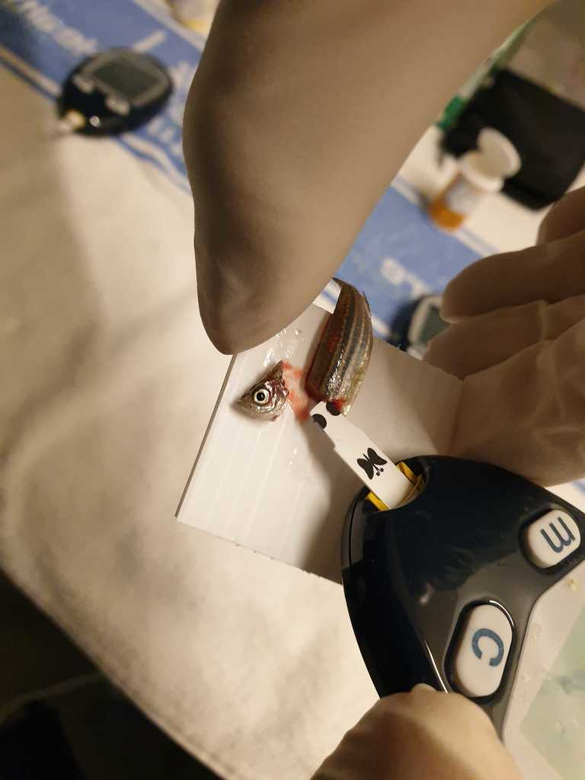Figure ) Point of insertion to obtain glucose reading

# References

Bartoňková, J., Hyršl, P. and Vojtek, L. (2017) ‘Glucose determination in fish plasma by two different moderate methods’, *Acta Veterinaria Brno*. University of Veterinary and Pharmaceutical Sciences, 85(4), pp. 349–353.

Beecham, R. V., Small, B. C. and Minchew, C. D. (2006) ‘Using Portable Lactate and Glucose Meters for Catfish Research: Acceptable Alternatives to Established Laboratory Methods?’, *North American Journal of Aquaculture*. John Wiley & Sons, Ltd, 68(4), pp. 291–295. doi: 10.1577/A05-074.1.

Eames, S. C. *et al.* (2010) ‘Blood Sugar Measurement in Zebrafish Reveals Dynamics of Glucose Homeostasis’, *Zebrafish*. Mary Ann Liebert, Inc., publishers, 7(2), pp. 205–213. doi: 10.1089/zeb.2009.0640.

Gleeson, M., Connaughton, V. and Arneson, L. S. (2007) ‘Induction of hyperglycaemia in zebrafish (Danio rerio) leads to morphological changes in the retina’, *Acta Diabetologica*, 44(3), pp. 157–163. doi: 10.1007/s00592-007-0257-3.